**DAILY ONLINE ACTIVITIES SUMMARY**

|  |  |  |  |  |  |  |  |  |
| --- | --- | --- | --- | --- | --- | --- | --- | --- |
| **Date:** | **30/05/2020** | | | | | **Name:** | **AKASH S** | |
| **Sem & Sec** | **4TH&A** | | | | | **USN:** | **4AL18CS004** | |
| **Online Test Summary** | | | | | | | | |
| **Subject** | | **1.DATA COMMUNICATION**  **2.COMPLEX ANALYSIS,PROBABILITY AND STASTICAL METHOD** | | | | | | |
| **Max. Marks** | | **1. 30**  **2. 30** | | **Score** | | | **1. 27**  **2. 27** | |
| **Certification Course Summary** | | | | | | | | |
| **Course** | **CLOUD FOUNDATIONS** | | | | | | | |
| **Certificate Provider** | | | **GREATLEARNING** | | **Duration** | | | **4.5 HOURS** |
| **Coding Challenges** | | | | | | | | |
| **Problem Statement:1:** **Write a C Program to count Uppercase, Lowercase, special character and numeric values for a given string.** | | | | | | | | |
| **Status: executed** | | | | | | | | |
| **Uploaded the report in Github** | | | | | **YES** | | | |
| **If yes Repository name** | | | | | <https://github.com/akashacharya786/lockdown-c-coding>  **https://github.com/akashacharya786/lockdown-java-coding** | | | |
| **Uploaded the report in slack** | | | | | **YES** | | | |

Online Test Summary 1: 18CS46 online test was scheduled from 9:15 amm to 10:00am. The portion for the IA was 3rd and 4th module. The question were MCQ type There were 30 question 1 mark respectively duration is 50 minutes .The score I received was 27/30.

Online Test Summary 2: 18KAK49 online test was scheduled from 3:00am to 3:40 am. The portion for the IA was 3rd module. The question were MCQ type There were 30 question 1 mark respectively duration is 40 minutes .The score I received was 27/30.

Snap shot:

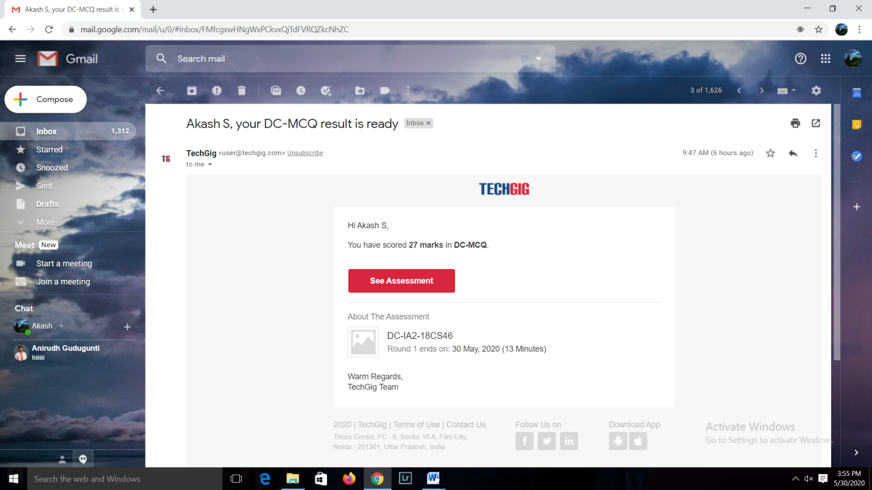

**Online Certification course:**

Today I started a new certification course

Name of the course : cloud foundation

Duration:4.5 hours

Certificate provider: great learning

The course contains 11 modules . Today I completed 3module.

This the snapshot of the new course:

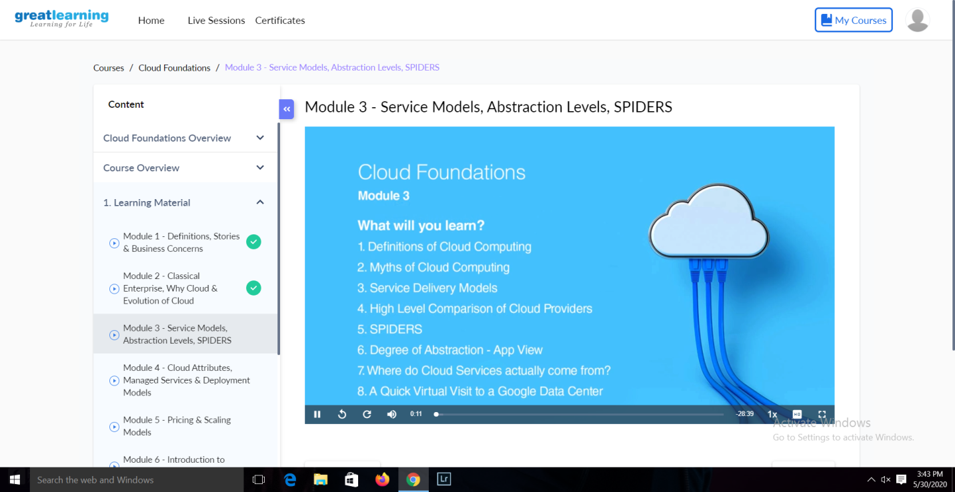

Online Coding summary:

1. **:** **Write a C Program to count Uppercase, Lowercase, special character and numeric values for a given string.**

